**Smallville Database Design Document**

**Version 1.0**

**Submittal Date: 11/24/2021**

|  |  |
| --- | --- |
| Version | Description |
| 1.0 | First release draft with ERD , EERD , and RS |

**Table of Contents**

**Topic Page**

**Purpose…………………………………………………………………………………………4**

**Narrative……………………………………………………………………………………….4**

**Requirements (Actors/Roles)………………………………………………………………….6**

**Entities………………………………………………………………………………………….6**

**Entities(w/ Nested Attributes)………………………………………………………………7-8**

**Business Rules…………………………………………………………………………………..9**

**ERD……………………………………………………………………………………………..10**

**EERD……………………………………………………………………………………………11**

**RS………………………………………………………………………………………………12**

**Purpose**

The purpose of this Database Design Document (DBDD) is to Oversee the majority of the functions that occur in a the Smallville company

**Narrative**

Smallville is the code name for a BPR project at a large enterprise where the leadership   
team wants to create a data model based on the company’s new business process models. This is   
a privately-owned business earning millions of dollars in revenue while being operated by just a   
handful of individuals. They want to create a data model for a tracking system for employee   
compensation costs, customer sales orders, product revenue monitoring, and inventory ordering.   
They have previously been running the whole business with excel spreadsheets going back and   
forth between each manager.   
The ordering business process has customers who place orders for products that   
Smallville sells. Customers are tracked by a customer number, first name, last name, address,   
email and phone. Products are tracked by product number, description (name), quantity on hand,   
whether on back order (yes/no), quantity on back order, “list price”, discount rate, and actual   
price (calculated from list price and discount rate). Product orders are tracked by order date,   
quantity of each product ordered, the quoted price, and net sale (calculated from quantity and   
price). A customer order will consist of at least one or more products, and products are   
associated with their orders for reporting purposes. In other words, not every product is ordered   
every time.   
Customer service process happens when a customer places an order and the associate   
assigned to the customer runs a product report to find out if units are on hand or if the product is   
on back order. An associate is assigned to a customer for each event when a customer contacts   
the company. Each event is tracked by date and time, and a short description of the event   
type/purpose. Products are only entered during the ordering process if they are available on hand.

The inventory monitoring process involves products on back order, a product line order is   
placed with one of Smallville’s suppliers. The product line order tracks the supplier, the product   
ordered, quantity, date of order, and expected arrival (calculated as 5 days forward of the order   
date).   
Smallville has four types of employees that handle the day to day operations of the   
company: Sales Reps, Hourly Workers, Salary Workers and Interns. Sales Reps are compensated   
by a commission rate times the number of units sold for an order credited to the Sales Rep. This   
is not the same as being assigned to a customer event.   
Hourly Workers fulfill customer orders and are tracked by hours worked per shift. Due to   
the nature of the business, workers can work more than one shift in a single day. Their   
compensation is calculated based on an hourly rate and the total hours worked for a given time-  
period. Salary workers receive a fixed annual compensation (“salary”). They are the leadership   
team and operations managers. Interns have no specific attributes unique to their type. All   
employees are listed by first name, last name, address, email and phone.   
Managers supervise hourly workers, sales reps, interns and some salaried employees. A   
manager may have one or more employees to supervise. No employee has more than one   
manager. Some employees are rated as managers but have no one to supervise. Not every   
employee has a manager. For example, the CEO has no manager.   
Each Customer is assigned a Sales Rep who is credited with all the product units the   
customer orders. If a Sales Rep is on vacation, a secondary Sales Rep may be assigned credit for   
handling a customer order transaction. Given that this is a commission business, Sales Reps   
usually carry more than one customer at a time. A Sales Rep is assigned at least one customer as

soon as they are hired into the role. Commissions are calculated in two parts. Part one is set at a   
fixed rate per order, and part two is an additional percentage rate for each product based on   
number of product units sold in an order.   
Smallville tracks its suppliers as part of its inventory ordering business process. Some   
products have more than one supplier and some suppliers offer more than one product. Suppliers   
are tracked by their company name, address, and phone.

**Requirements (Actors and Roles)**

**Customer – Customers that come in to buy the product . Customers are assigned a Associate representative**

**Product- Products are the products that the company is selling**

**Product Orders- Product orders are the orders that come in from the supplier**

**Customer Order- Customer orders are the orders that come in from the customer and originate from the product on hand that the company has**

**Customer Service Process- The event for the customer processing which includes date and time and details of the purpose of the call / communication**

**Inventory Monitoring Process- Processing of the products that come in from the supplier and transition themselves into the warehouse/company**

**Supplier- Suppliers that are used for the inventory monitoring process**

**Employees- Employees that help the customers out with the services of the company or operations**

**Entities**

**Customer**

**Product**

**Product Order**

**Customer Order**

**Customer Service Process**

**Inventory Monitoring Process**

**Supplier**

**Employees**

**Employee Type**

**Entities w/Nested Attributes**

* **Customer**
  + **CustomerID**
  + First Name
  + Last Name
  + Address
  + Phone Number
  + Email
* **Product**
* **ProductID**
* Name
* Description
* Quantity on Hand
* Back Order (Y/N)
* **Product Order**
* **OrderPID**
* Date
* Quantity
* Quoted Price
* NetSale Quantity/Price
* **ProductID FN**
* **Customer Order**
  + **OrderCID**
  + Customer FN
  + Date
* **Customer Service Process**
  + **ProcessID**
  + CustomerID FN
  + EmployeeID FN
  + Date
  + Time
  + Event
* **Inventory Monitoring Process**
  + **MonitoringID**
  + Backorder
  + Charge
  + Date
  + Time
  + Name
  + Supplier
* **Supplier**
  + **SupplierID**
  + **Company Name**
  + **Address**
  + **Phone**
* **Employee**
* EmployeeID
* First Name
* Last Name
* Address
* Email
* Phone
* EmployeeType
* ManagerID

**Business Rules** :

Customer – Will consist of at least one or more products . Products are associated with their orders for reporting purposes. Not every product is ordered every time. Customer is assigned a sales rep who is credited with all the product units the customer orders .

Employee –Associate is assigned to a customer for each event when a customer contacts the company. There is 4 types of employees . Employees can have a manager but not every employee has a manager / supervision. If associate is vacation . secondary sales rep may be assigned credit for handling customer order transaction . Sales rep can have more than one customer at a time . Sales rep is assigned to at least one customer as soon as they are hired on .

Product – Only entered during the ordering process if they are available on hand

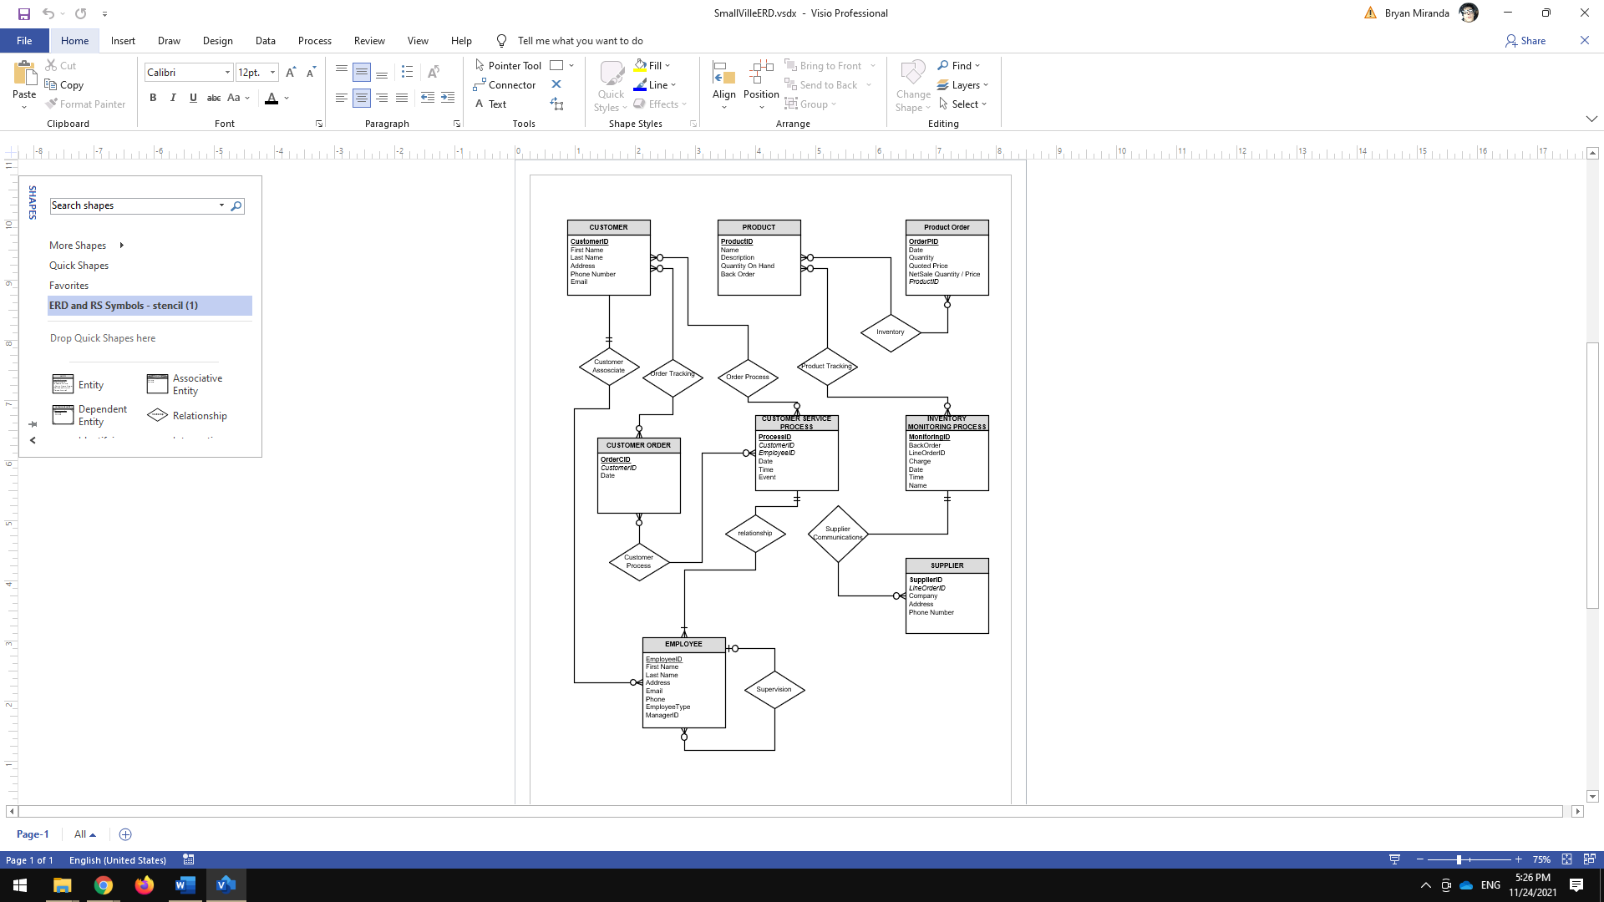ERD MODEL

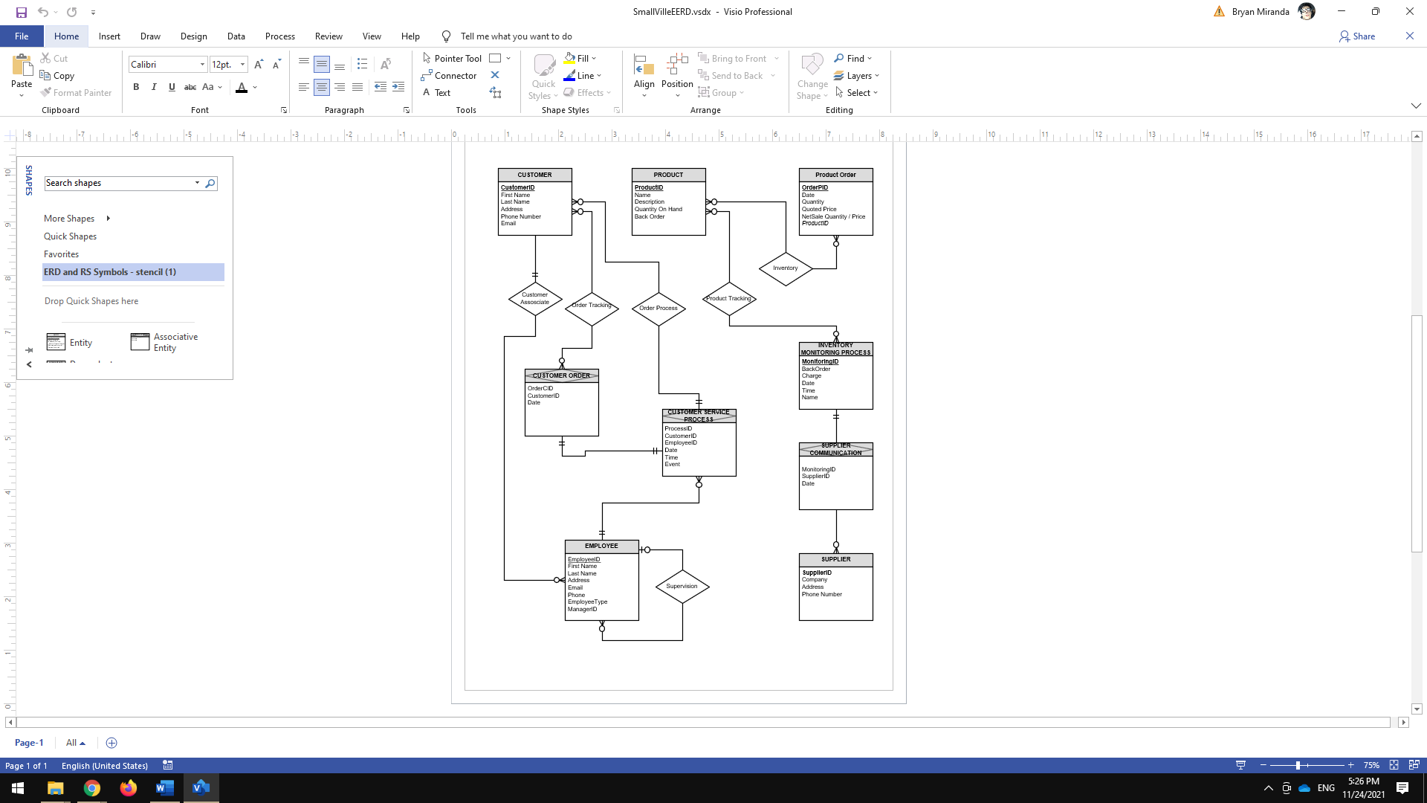EERD MODEL

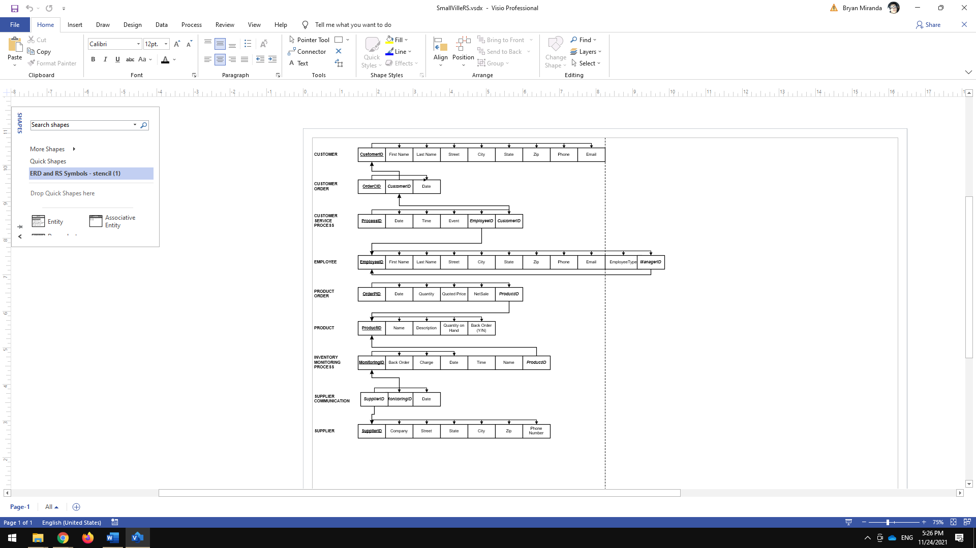SMALLVILLE RELATIONAL SCHEMA